NEGATIVE STOCK BLOCKING
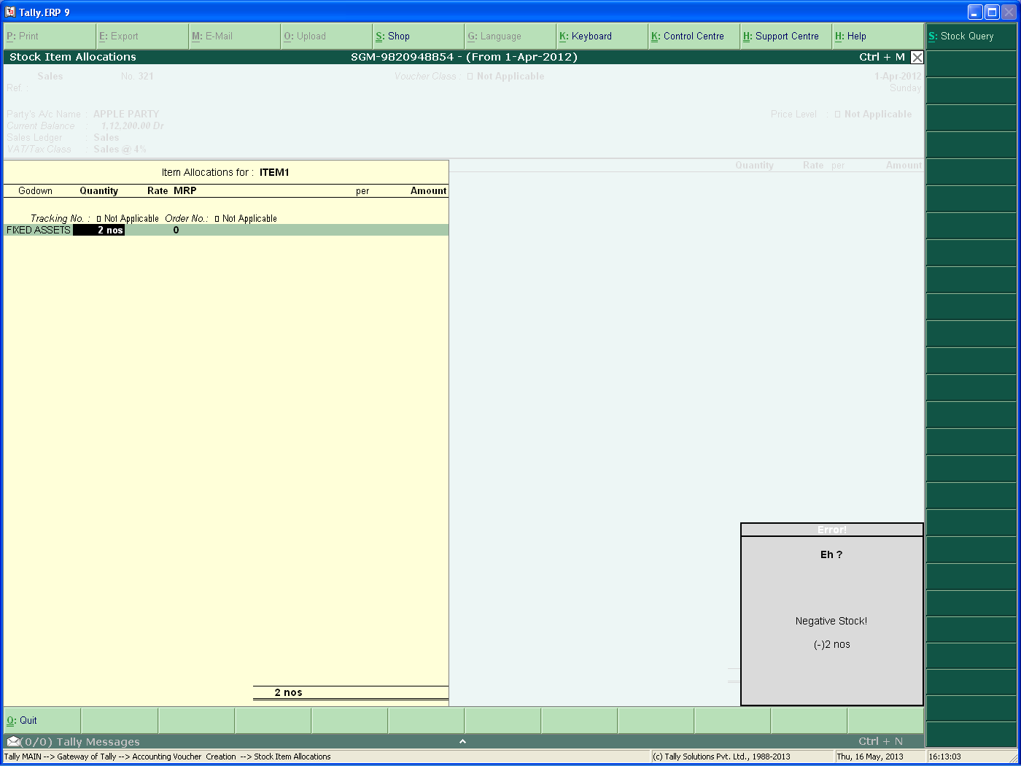
Negative Stock Block

